Buhi Social Media Audit
Facebook
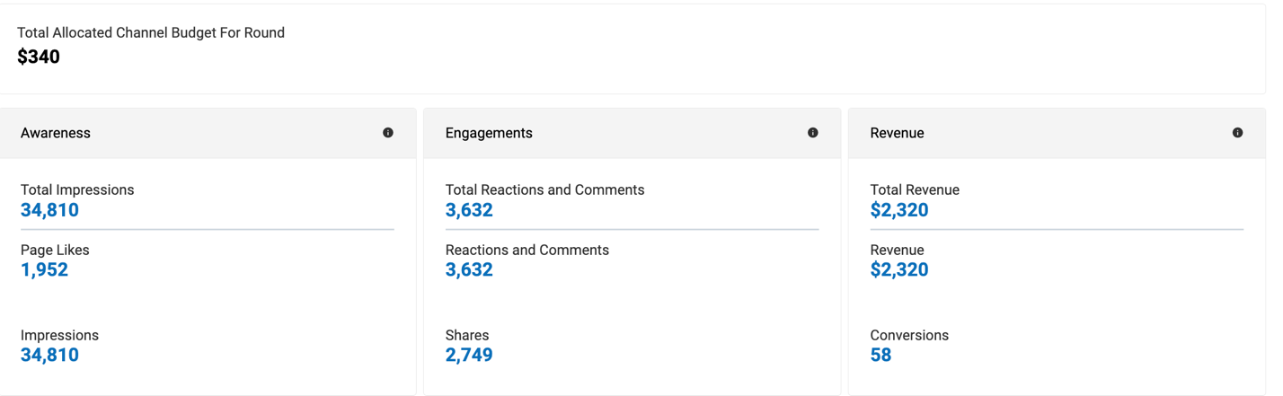
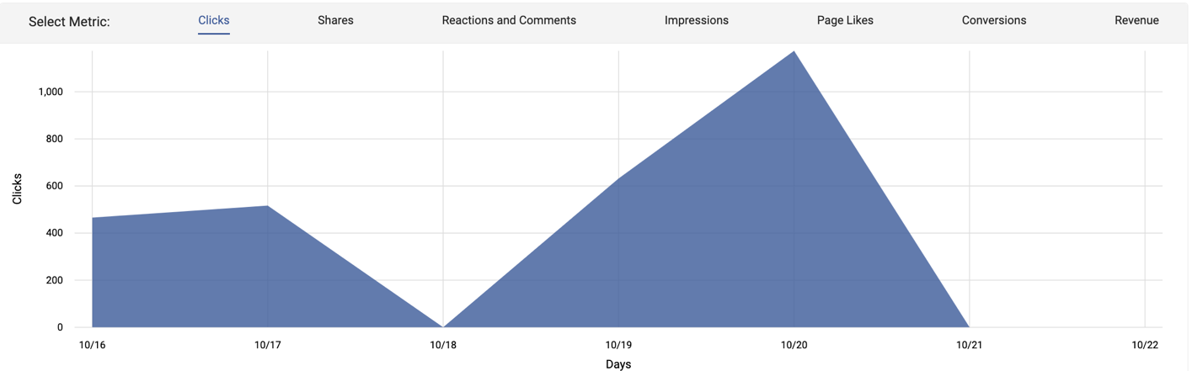
Excel Spreadsheet
Column1 | Column2 | Column3 | Column4
Social Media Networks | Posting Frequency | Average # of Engagements, Reach, Clicks | Type of Content Shared
Facebook | 2x/week | 40,000 | School, travel
Instagram | 1x/week | 65,000 | School, travel
Pinterest | 1x/week | 700 | School, travel
Twitter | 1x/week | 800
TikTok | 0x/week | 6,000
Total

Social Media and Target Audience:
Daypacker Tom: Collects bulk of market share
Demographics:
- Age: 24-31
- Gender: Male
- Income: $25,000-$35,000
- Active lifestyle, enjoys the outdoors, hiking, fishing, etc.
- Key product features:
  - Versatile
  - Functional
  - Spacious
  - Styled

Summary:
- Facebook
- Checks app at least once a day
  - Popular posting times:
    - Thursdays – 9am, 1pm, 3pm
    - Fridays – 9am, 1pm, 3pm
    - Saturdays – 9am, 1pm, 3pm
  - Content should promote function and versatility
- Twitter:
- Checks app at least one a day
  - Popular posting times:
    - Wednesdays – 12pm, 3pm, 5pm
  - Content should help build awareness
- Instagram:
- Checks app multiple times a day
  - Popular posting times:
    - Mondays – 2am, 8am
    - Thursdays – 2am, 8am, 5pm

