Buhi Social Media Audit
Facebook
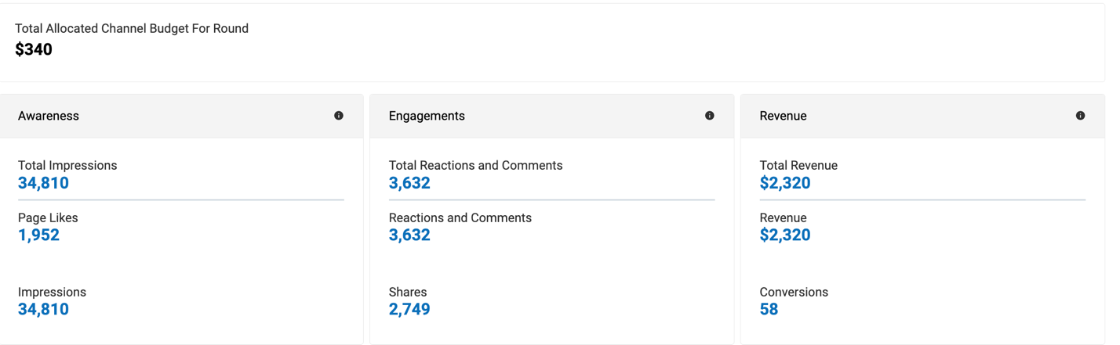
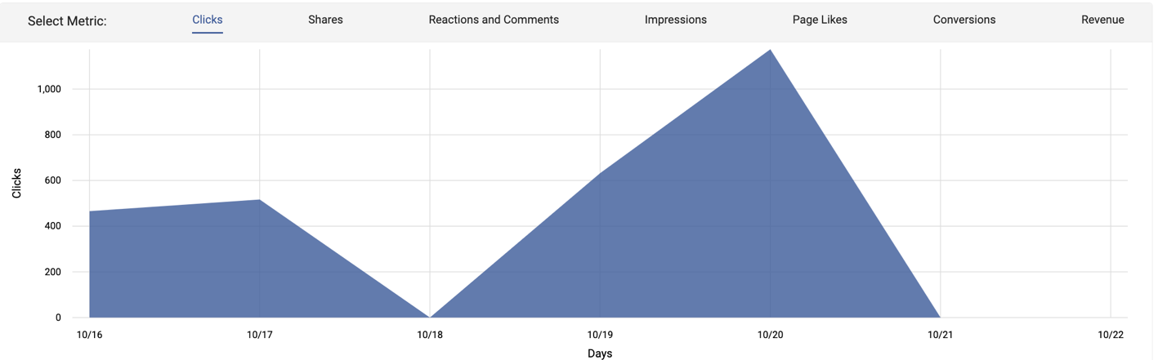

Excel Spreadsheet
Column1 | Column2 | Column3 | Column4
Social Media Networks | Posting Frequency | Average # of Engagements, Reach, Clicks | Type of Content Shared
Facebook | 2x/week | 40,000 | School, travel
Instagram | 1x/week | 65,000 | School, travel
Pinterest | 1x/week | 700 | School, travel
Twitter | 1x/week | 800
TikTok | 0x/week | 6,000
Total

SWOT Analysis
Strengths: Affordable prices
Weaknesses: Not enough brand recognition
Opportunities: Working with industry influencers
Threats: Tough competition, tough job market

Summary:
- Social media channels that need to be monitored are Instagram, Facebook, Pinterest, and Twitter.
- List of keywords: “back to school/school”, “vacation”, “travel”, “fitness/gym”,
- Twitter, Pinterest, and YouTube don’t have the best engagements
- Facebook, Instagram and TikTok has thousands of awareness and engagements

